|  |
| --- |
| **Finnish united** |
| SP4 |
| Muhammad Salihin Bin Zaol-kefli 120412D  Kinnear Justin Wong 124363F  Fong Zhi Zhong, Keith 121602A |
|  |
|  |
|  |

|  |
| --- |
| This document contains details on Dungeoners done for DM2295 Game Development Project |

**TABLE OF CONTENTS**

1. **GAME IDEA & DESCRIPTION**

* Game Concept Page
* Game Genre Page
* References Page
* Target Audience Page

1. **GAME OVERVIEW**

* Game Goal Page
* Gameplay Page
* Story Page
* Unique Selling Points Page
* Game Features Page
* Individual Task List Page

1. **PROJECT SCHEDULE**

* Gantt Chart Page

1. **KNOWLEDGE APPLIED**

* Physics Page
* Advanced Games Development Techniques Page
* Multiplayer Games Programming Page
* Artificial Intelligence in Games Page
* Production and Project Management Page
* Interface Design and Programming Page

1. **CODE SNIPPETS** Page
2. **SCREENSHOTS** Page
3. **LESSONS LEARNT** Page
4. **FUTURE ENHANCEMENTS** Page
5. **SUMMARY** Page

**GAME IDEA & DESCRIPTION**

**Game Concept**

Dungeoners is a multiplayer game that involves co-operation and quick reactions on the player’s part. Dungeoners caters to 4 players only.

**Game Genre**

First Person, Hack and Slash, Multiplayer

**References**

The Binding of Isaac

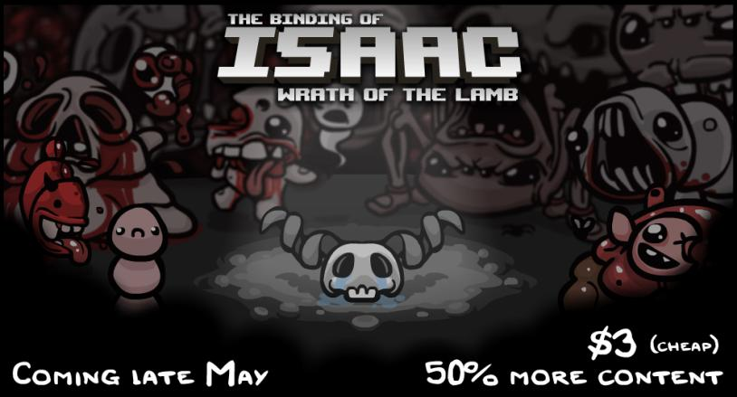

Chivalry

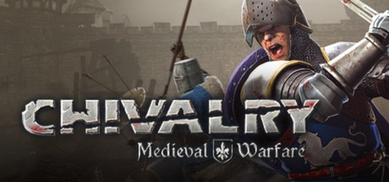

**Target Audience**

Teenagers and Young Adults

**GAME OVERVIEW**

**Game Goal**

Players have to get to the safe point and get to the next level alive.

**Gameplay**

All the connected players are placed in a dungeon. There must be 4 players in order to play the game.

The objective of the players is to get to the safe point and get to the next level alive.

The level is full of rooms. All players will start off the game by being spawned in the same room. Players will have to make their way through the various rooms and eventually get to the same point to progress to the next level.

Each room has 4 walls with a door per wall. Some doors are already opened while others are locked. Upon moving from 1 room to another through a door, that door can close randomly to separate the players.

Each room will have monsters, weapons and power ups. Players can only hold onto 1 power up at a time. The power ups will affect the way players play the game.

**Story**

**Unique Selling Points**

* Multiplayer
* Dark environment thus requiring players to depend on their instincts and hearing to move around and explore the level

**Game Features**

* Main menu
* Credits
* Tutorial Level
* Main Level
* Achievements
* Controller / Keyboard input
* Sound
* Multiplayer
* User Interface

**Individual Task List**

Salihin

* User Interface for the different pages in the game and in-game
* Sound (loading background music and sound effects)
* Triggers for Sound Effects
* Multiplayer (limiting of number of players, lobby)

Kinnear

* Object interaction
* Player movement
* Triggers for traps
* In game triggers

Keith

* Multiplayer (setting up of server, basic client, managing data)
* Animation of models
* Chatter
* Artificial Intelligence

**PROJECT SCHEDULE**

**Gantt Chart**

|  |  |  |  |  |  |  |  |  |  |  |  |  |  |  |  |  |
| --- | --- | --- | --- | --- | --- | --- | --- | --- | --- | --- | --- | --- | --- | --- | --- | --- |
| **Task** | **Duration** | **Week 1** | | | | | **Week 2** | | | | | **Week 3** | | | | |
| Setting up Scenes needed for game | 1 |  |  |  |  |  |  |  |  |  |  |  |  |  |  |  |
| User interface framework | 1 |  |  |  |  |  |  |  |  |  |  |  |  |  |  |  |
| Sound framework | 1 |  |  |  |  |  |  |  |  |  |  |  |  |  |  |  |
| UI for splash screen | 1 |  |  |  |  |  |  |  |  |  |  |  |  |  |  |  |
| Design UI for lobby | 1 |  |  |  |  |  |  |  |  |  |  |  |  |  |  |  |
| In game GUI | 1 |  |  |  |  |  |  |  |  |  |  |  |  |  |  |  |
| Multiplayer (limiting of players, lobby) and UI design | 2 |  |  |  |  |  |  |  |  |  |  |  |  |  |  |  |
| Multiplayer (setting up of server, basic client, managing data) | 3 |  |  |  |  |  |  |  |  |  |  |  |  |  |  |  |
| Triggers for Sound Effects | 1 |  |  |  |  |  |  |  |  |  |  |  |  |  |  |  |
| Integrating of some Art assets for UI | 2 |  |  |  |  |  |  |  |  |  |  |  |  |  |  |  |
| Loading of Sounds | 1 |  |  |  |  |  |  |  |  |  |  |  |  |  |  |  |
| Player movement | 1 |  |  |  |  |  |  |  |  |  |  |  |  |  |  |  |
| Object interaction | 2 |  |  |  |  |  |  |  |  |  |  |  |  |  |  |  |
| Chatter | 3 |  |  |  |  |  |  |  |  |  |  |  |  |  |  |  |
| Artificial Intelligence for enemies | 2 |  |  |  |  |  |  |  |  |  |  |  |  |  |  |  |
| Mid Presentation | 1 |  |  |  |  |  |  |  |  |  |  |  |  |  |  |  |
| Trigger traps and other in game triggers | 5 |  |  |  |  |  |  |  |  |  |  |  |  |  |  |  |
| Animation of models | 2 |  |  |  |  |  |  |  |  |  |  |  |  |  |  |  |
| Trigger win/lose game | 1 |  |  |  |  |  |  |  |  |  |  |  |  |  |  |  |
| UI for Gameover screen | 1 |  |  |  |  |  |  |  |  |  |  |  |  |  |  |  |
| Integration of Art assets | 3 |  |  |  |  |  |  |  |  |  |  |  |  |  |  |  |
| Testing and balancing of game | 3 |  |  |  |  |  |  |  |  |  |  |  |  |  |  |  |
| Debugging | 3 |  |  |  |  |  |  |  |  |  |  |  |  |  |  |  |
| Final Report | 1 |  |  |  |  |  |  |  |  |  |  |  |  |  |  |  |
| Final presentation slides | 1 |  |  |  |  |  |  |  |  |  |  |  |  |  |  |  |
| Video | 1 |  |  |  |  |  |  |  |  |  |  |  |  |  |  |  |
| Final Presentation | 1 |  |  |  |  |  |  |  |  |  |  |  |  |  |  |  |

**Legend**

|  |  |
| --- | --- |
| **Salihin** |  |
| **Kinnear** |  |
| **Keith** |  |
| **All** |  |

**KNOWLEDGE APPLIED**

**Physics**

**Advanced Games Development Techniques**

**Multiplayer Games Programming**

**Artificial Intelligence in Games**

**Production and Project Management**

**Interface Design and Programming**

**CODE SNIPPETS**

Salihin

Kinnear

Keith

**SCREENSHOTS**

**LESSONS LEARNT**

**FUTURE ENHANCEMENTS**

* Handle more players
* More levels
* Randomly generate rooms
* Unlockable items

**SUMMARY**